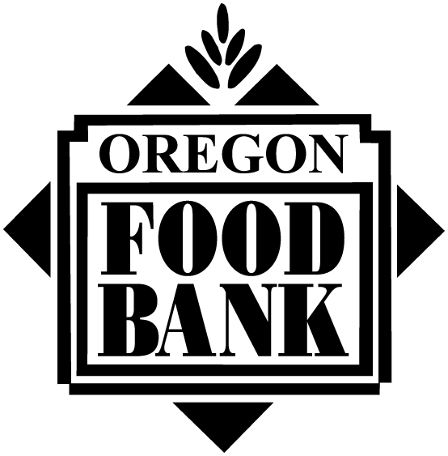

OREGON FOOD BANK
WASTE/NON-EDIBLE FOOD AGREEMENT
FORM OF RELEASE

Oregon Food Bank (OFB) is a private, non-profit corporation organized to secure donations of edible food that would otherwise be destroyed. This food is then redistributed to needy families and individuals in Oregon through its network of Regional Food Banks (RFBs). From time to time, OFB and/or an RFB will receive food that is unfit for human consumption but that can still be used for animal feed providing that the individuals meet the OFB criteria outlined below:

- The individuals will use such items for animal feed only.
- The individuals will use such items received from OFB/RFB on site and not use these products elsewhere.
- The individuals will agree to allow OFB representatives to conduct a site visit of the feeding operation and review the end use of the non-edible food.
- The individuals will accept full responsibility for the purity and fitness of any and all food items accepted.
- The individuals will recognize that OFB, the RFB, and the primary donor have specifically disclaimed any warranties or representations, expressed or implied, as to the purity or fitness of any and all food items accepted.
- The individuals will warrant and guarantee to OFB, the RFB, and the primary donor that the latter parties shall not be susceptible to any liabilities, claims, losses, causes of action, or suits of law arising out of or attributed to any action done by the individuals in connection with the storage and/or use of the items supplied to them by OFB or the RFB.
- The individuals will agree to comply with all local, state, and federal rules and regulations which apply to handling, use, and/or disposal of non-edible foods.
- The individuals, in compliance with state and federal laws, will neither offer for sale, sell, transfer, nor barter the items supplied by OFB/RFB in exchange for money, other properties, or services.
- An authorized representative of the individuals will sign a receipt provided to them at the time the product is received. A copy of the receipt will be kept on file with the individuals.
- The individuals will agree to pay assessed shared maintenance contributions to OFB or the RFB for product received.

By signing below the individuals affirm that the above conditions are agreed to and will be abided by.

AUTHORIZED REPRESENTATIVE AVG REPRESENTATIVE

AGENCY/FARM NAME DATE

ADDRESS

CITY/STATE/ZIP

PHONE DATE

